Volatility Modelling Using GARCH Family Models

Objective
After fitting ARIMA models to the return series of AAPL, MSFT, and SPY, residual diagnostics indicated the presence of conditional heteroscedasticity. Therefore, GARCH-family models were employed to model the time-varying volatility remaining in the ARIMA residuals and to generate conditional volatility series for the development of the A-CMSI framework.

Apple Inc. (AAPL)
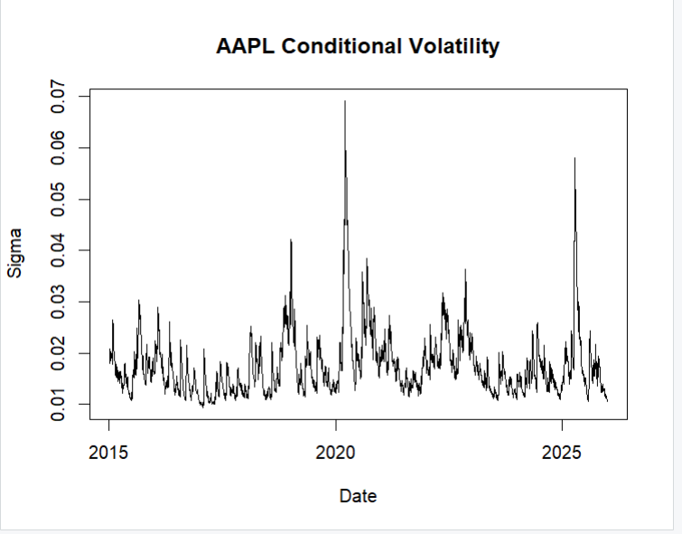
Model Specification
- Mean Model: ARIMA residual series
- Variance Model: sGARCH(1,1)
- Distribution: Student-t
Parameter Estimates
Parameter | Estimate
ω (omega) | 8.79 × 10⁻⁶
α₁ | 0.1019
β₁ | 0.8780
Shape | 4.5325
Volatility Persistence
α₁ + β₁ = 0.9799
This indicates very high volatility persistence. Volatility shocks decay slowly over time.

Diagnostic Tests
Standardized Residual Ljung-Box Test
Residual autocorrelation remained significant (p < 0.05), indicating some remaining serial dependence in standardized residuals.
Squared Residual Ljung-Box Test
All p-values > 0.05.
Conclusion:
No significant autocorrelation remains in squared residuals.
ARCH-LM Test
All p-values > 0.05.
Conclusion:
No remaining ARCH effects exist after fitting the model.
Sign Bias Test
All p-values > 0.05.
Conclusion:
No evidence of asymmetric volatility.
Nyblom Stability Test
Joint Statistic = 11.1505
Critical Value (1%) = 1.60
Conclusion:
Parameter instability exists across the sample period, likely due to structural market events such as the COVID-19 shock.

Final Assessment
The sGARCH(1,1) model successfully captured volatility clustering in AAPL residuals and produced a valid conditional volatility series.

2. Microsoft Corporation (MSFT)
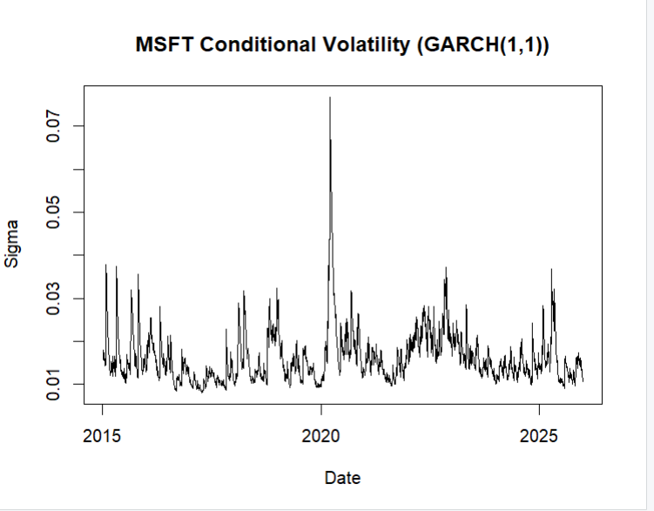
Model Specification
- Mean Model: ARIMA residual series
- Variance Model: sGARCH(1,1)
- Distribution: Student-t
Parameter Estimates
Parameter | Estimate
ω (omega) | 7.66 × 10⁻⁶
α₁ | 0.1197
β₁ | 0.8639
Shape | 4.3793
Volatility Persistence
α₁ + β₁ = 0.9837
This indicates strong persistence of volatility shocks.

Diagnostic Tests
Standardized Residual Ljung-Box Test
Residual autocorrelation remained significant.
Squared Residual Ljung-Box Test
All p-values > 0.05.
No remaining volatility clustering detected.
ARCH-LM Test
All p-values > 0.05.
No remaining ARCH effects detected.
Sign Bias Test
All p-values > 0.05.
No evidence of asymmetric volatility.
Nyblom Stability Test
Joint Statistic = 8.0878
Critical Value (1%) = 1.60
Conclusion:
Parameters exhibit instability over the sample period.

Final Assessment
The sGARCH(1,1) model adequately captured conditional heteroscedasticity and generated a valid volatility series for MSFT.

3. SPY ETF
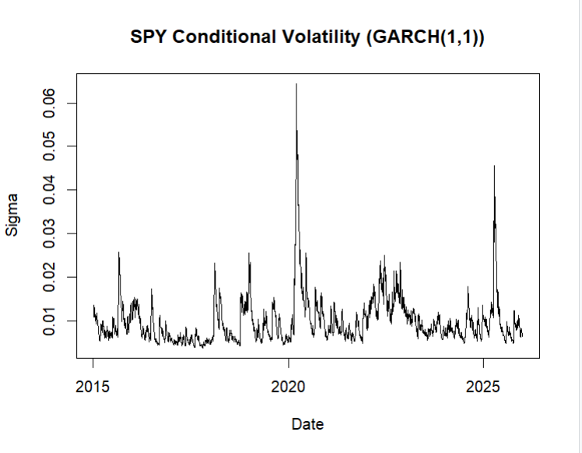
Initial Model: sGARCH(1,1)
Parameter Estimates
Parameter | Estimate
ω (omega) | 1.94 × 10⁻⁶
α₁ | 0.1584
β₁ | 0.8367
Shape | 5.7162
Volatility Persistence
α₁ + β₁ = 0.9950
This indicates extremely persistent volatility.

Diagnostic Findings
Sign Bias Test
Sign Bias p-value < 0.001
Conclusion:
Evidence of asymmetric volatility effects remained.
Nyblom Stability Test
Joint Statistic = 49.2929
Conclusion:
Severe parameter instability.
These findings suggested that the symmetric GARCH specification was inadequate for SPY.

4. EGARCH Model for SPY
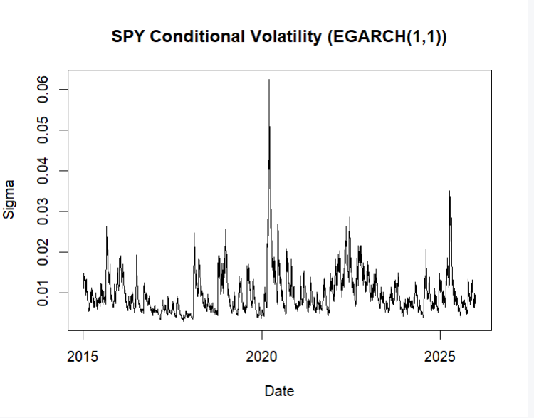
To account for asymmetric volatility dynamics, an EGARCH(1,1) model was estimated.
Parameter Estimates
Parameter | Estimate
ω (omega) | -0.3087
α₁ | -0.1752
β₁ | 0.9677
γ₁ | 0.1890
Shape | 6.1427
Asymmetry Parameter
γ₁ = 0.1890
Statistically significant (p < 0.001)
Conclusion:
SPY exhibits asymmetric volatility behaviour, confirming that volatility reacts differently to market shocks.

Model Comparison
Metric | sGARCH | EGARCH
Log-Likelihood | 9229.52 | 9286.04
AIC | -6.6755 | -6.7157
BIC | -6.6669 | -6.7049
EGARCH achieved:
- Higher log-likelihood
- Lower AIC
- Lower BIC
- Improved parameter stability

5. GJR-GARCH Comparison
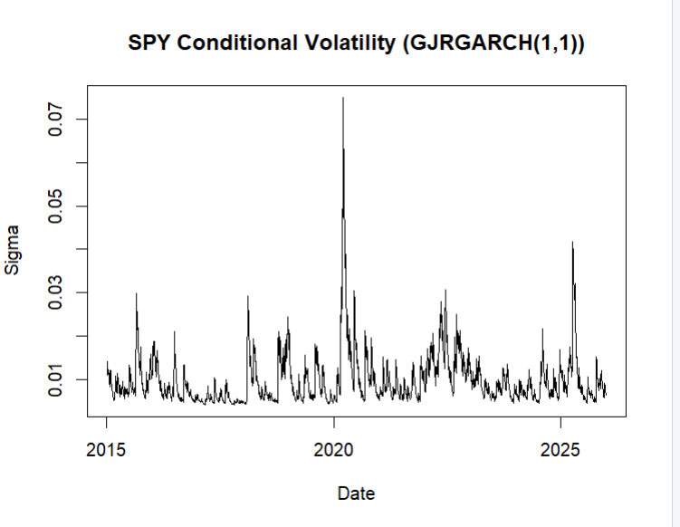
A GJR-GARCH(1,1) model was also estimated.
Metric | GJR-GARCH
Log-Likelihood | 9276.18
AIC | -6.7085
BIC | -6.6978
Although GJR-GARCH captured asymmetry, its information criteria were inferior to EGARCH and parameter stability remained weaker.
Therefore, EGARCH was selected as the preferred model for SPY.

Final Model Selection
Asset | Selected Model
AAPL | sGARCH(1,1)
MSFT | sGARCH(1,1)
SPY | EGARCH(1,1)

Conclusion
The GARCH-family modelling stage successfully captured conditional heteroscedasticity present in the ARIMA residuals of all three assets.
For AAPL and MSFT, symmetric GARCH models were sufficient, while SPY demonstrated statistically significant asymmetric volatility effects that were better captured using an EGARCH specification.
The resulting conditional volatility series were extracted and stored for subsequent use in the construction of the AI-COVID Market Stress Index (A-CMSI). These volatility measures represent dynamic estimates of market uncertainty and will serve as key inputs in the next phase of index development.

